HI520 Unit 2 Assignment

Amari Swain

2023

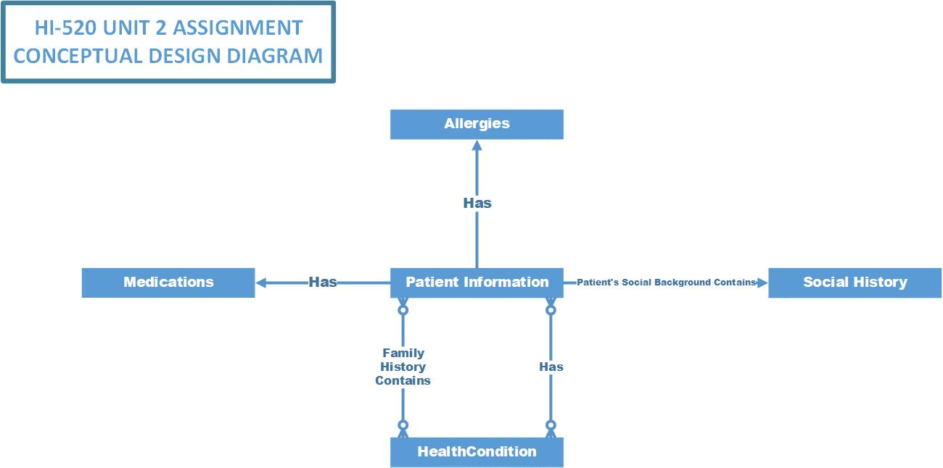

Entities:

Patient Information- I concluded Patient Information should go in the middle because all other entities all lead back to its which means it’s the patient. The information in this entity should consist of Name, DOB, Gender, Patient Identification.

Medications- This is the next entity I chose, since this is a database meant to hold all a patient’s health information. It needs to include all medication the given patient is currently taking. It should include the name, dose, and times per day taken.

Medication has a relationship with patient information because it is the patient’s medication, we are taking note of. I used to “Has” because it relates to what medication the patient currently has and if the patient doesn’t take medication there will be no information taken.

Social History- I chose social background as the next entity to connect. Social history is important because it holds information about the patients outside of the medical information. This information can be important because it brings in the patient’s life, the information should include occupation, employer, years of education/highest degree, employed during night shift, marital status, and children and amount. I feel this information gives insight on a patient and having this information can help with diagnoses or reaching out to family members if needed.

When it comes to social history it relates to the patient information because it is the background of the patient. It will tell the provider who the patient is on a social level outside of their health history. I defined the relation between the two as the patient’s social background.

Allergies- For the last entity I chose to implement allergies. I did this because like medication allergies are important. This entity can help providers know how to handle a patient whether it’s a latex allergy or even medication implementing allergies to the database is an important entity and needs to be included.

When it comes to allergies I used “Has” to show the relationship between patient information and allergies. If a patient has no know allergies this will be left blank. Having allergies implemented will help providers using the database know what medications the patient isn’t able to take.